Using Zoom for the BLMD Annual Meeting
Be sure to download the Zoom app for your computer and/or mobile device from the download center. If not done in advance you will be prompted to download when you click the meeting link).

You do not need a Zoom account to attend a Zoom meeting. You can join Zoom by computer, tablet, smart phone or just dial in and listen.
If you are not familiar with Zoom here is a video on joining a zoom meeting. Zoom also offers a test meeting that you can join to familiarize yourself with the platform.

Participating from your Computer
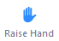
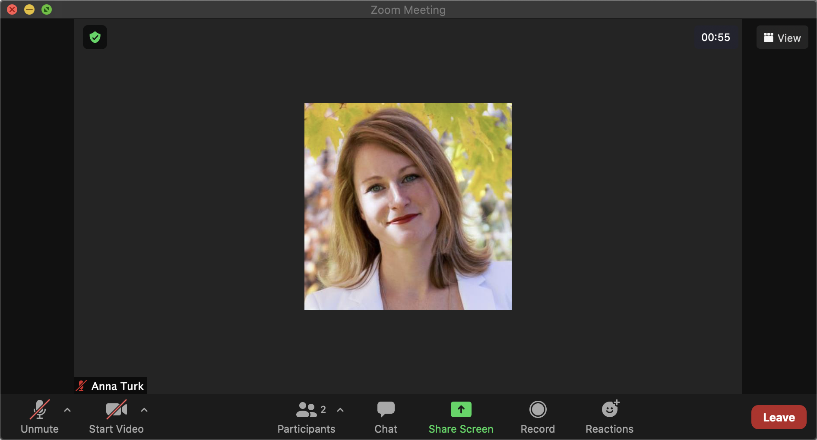
Change how you see participants in the meeting:
Speaker: active speaker will be in a large window and other attendees’ videos in a smaller tile.
Gallery: shows participants in a grid pattern.
Type a question to the host at any time during the meeting. Questions will be read out during the Q&A time to be answered by the BLMD Commissioners.

Click to view the full list of participants.
During the Q&A time, use the dfgffg button in the participant window to signify host that you would like to be unmuted to ask a question.

To minimize background noise, participants will be muted upon joining the meeting.
During the Q&A time there will be the opportunity to signal to the host that you have a question. When it is your turn, the host will announce your name and unmute you to ask your question.
You can turn your video on/off at any time during the meeting.

Participating from a mobile device

Tap the screen for the controls to appear on your mobile device. Mute, Video, and Participants all function similarly, refer to the above instructions.
The Raise Hand and Chat features will be within the icon.

The default will be Speaker view with additional participants in the bottom right, and you will swipe left to see additional participants. On an iPad the option to switch views is .

Participating from phone with audio only
Listening only to a Zoom meeting has limited features. You can Raise Hand by pressing *9, indicating to the host that you have a question. The host will unmute the caller when it is their turn to speak.

